CHAPTER 8: The dynamic Earth
© MAPgraphics Pty Ltd, Brisbane
Worksheet 8.5

Plotting earthquake activity
Student: Class:
The following table contains data for large earthquakes that have occurred in the Pacific Rim in the
last 100 years.
 | Magnitude | Location | Latitude | Longitude
A | 8.5 | Kuril islands | 45°N | 150°E
B | 8.5 | Argentina | 29°S | 71°W
C | 8.5 | Banda Sea | 5°S | 132°E
D | 8.6 | Tibet | 29°N | 96°E
E | 8.6 | Indonesia | 2°N | 97°E
F | 8.8 | Ecuador (off coast) | 1°N | 82°W
G | 9.0 | Kamchatka | 53°N | 160°E
H | 9.1 | Sumatra | 3°N | 96°E
I | 9.2 | Alaska | 61°N | 148°W
J | 9.5 | Chile | 38°S | 73°W
1. Plot the location of each earthquake on the map below.
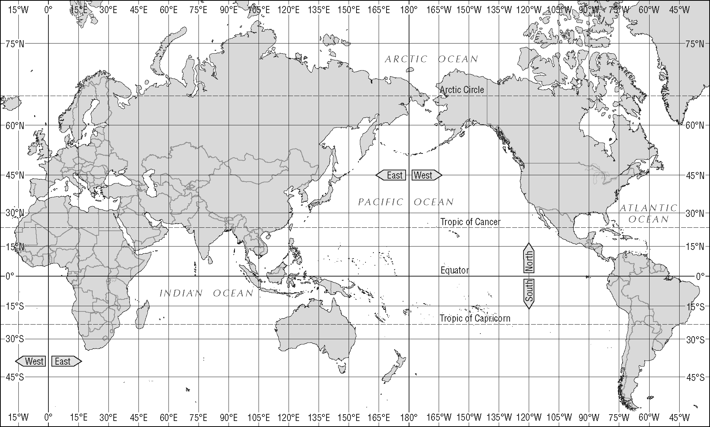

CHAPTER 8: The dynamic Earth
Worksheet 8.5

Page 2

2. Account for the location of these earthquakes in relation to the tectonic plates.

3. The Chilean earthquake occurred in 1960. What effect does an earthquake of this magnitude have on the ground surface?

